**Hive下载：**

在Docker Desktop中将Hive 4.0.0 pull下来，在终端以管理员身份启动并进入容器

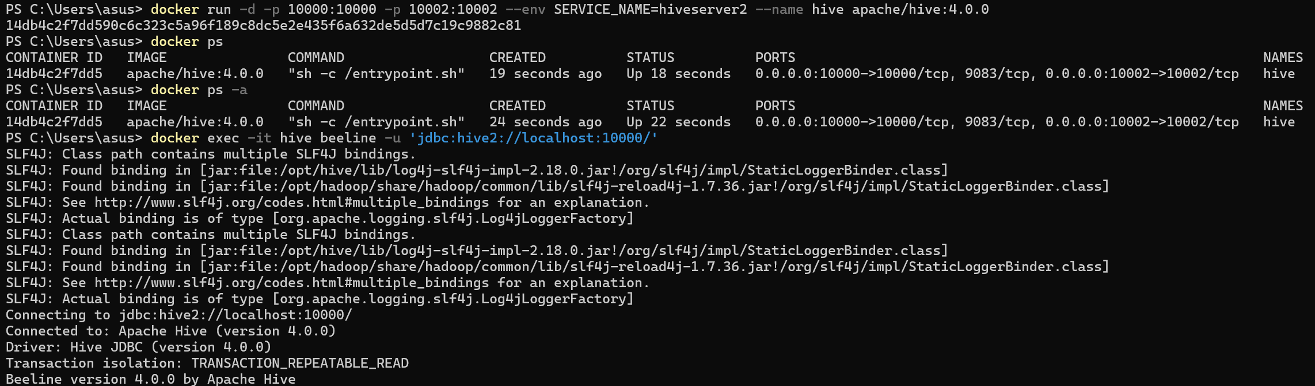

**数据准备：**

将user_profile_table.csv和user_balance_table.csv复制到hive的/tmp目录下



**Task1数据加载到Hive中：**

创建两张表格user_profile_table和user_balance_table：

|  |
| --- |
| CREATE TABLE user_profile_table (  user_id INT,  sex INT,  city INT,  constellation STRING  )  ROW FORMAT DELIMITED  FIELDS TERMINATED BY ','  STORED AS TEXTFILE  TBLPROPERTIES("skip.header.line.count"="1"); |
| CREATE TABLE user_balance_table (  user_id STRING,  report_date STRING,  tBalance DOUBLE,  yBalance DOUBLE,  total_purchase_amt DOUBLE,  direct_purchase_amt DOUBLE,  purchase_bal_amt DOUBLE,  purchase_bank_amt DOUBLE,  total_redeem_amt DOUBLE,  consume_amt DOUBLE,  transfer_amt DOUBLE,  tftobal_amt DOUBLE,  tftocard_amt DOUBLE,  share_amt DOUBLE,  category1 DOUBLE,  category2 DOUBLE,  category3 DOUBLE,  category4 DOUBLE  )  ROW FORMAT DELIMITED  FIELDS TERMINATED BY ','  STORED AS TEXTFILE  TBLPROPERTIES ("skip.header.line.count"="1"); |

之后将数据导入创建的表格：

|  |
| --- |
| LOAD DATA LOCAL INPATH '/tmp/user-profile_table.csv' INTO TABLE user_profile_table;  LOAD DATA LOCAL INPATH '/tmp/user-balance_table.csv' INTO TABLE user_balance_table; |

进行数据查询：

|  |
| --- |
| SELECT * FROM user_profile_table LIMIT 5; |
| SELECT * FROM user_balance_table LIMIT 5; |
| SELECT COUNT(*) FROM user_profile_table; |
| SELECT COUNT(*) FROM user_balance_table; |

**Task2基本数据查询：**

1. 查询星座⽤户数量

|  |
| --- |
| SELECT  constellation,  COUNT (*) AS user_count  FROM  user_profile_table  GROUP BY  constellation  ORDER BY  ser_count DESC; |

1. 查询特定⽇期的资⾦流⼊和流出情况

|  |
| --- |
| CREATE TABLE daily_flow_table AS  SELECT  report_date,  SUM(total_purchase_amt) AS total_inflow,  SUM(total_redeem_amt) AS total_outflow  FROM  user_balance_table  GROUP BY  report_date;  SELECT * FROM daily_flow_table LIMIT 20; |

**Task3数据聚合分析：**

1. 按星座统计总购买量和赎回量

|  |
| --- |
| SELECT  up.constellation,  SUM(ub.total_purchase_amt) AS total_purchase,  SUM(ub.total_redeem_amt) AS total_redeem_amt  FROM  user_profile_table up  JOIN  user_balance_table ub  ON  up.user_id = ub.user_id  GROUP BY  up.constellation; |

1. 按城市统计2014年3⽉1⽇的平均余额

|  |
| --- |
| SELECT  up.city,  AVG(ub.tBalance) AS avg_bal  FROM  user_profile_table up  JOIN  user_balance_table ub  ON  up.user_id = ub.user_id  WHERE  ub.report_date = '20140301'  GROUP BY  up.city  ORDER BY  avg_bal DESC  LIMIT 10; |

**Task4复杂查询与分析：**

1. 活跃用户分析

|  |
| --- |
| SELECT COUNT(DISTINCT user_id) AS total_active_usr  FROM (  SELECT  user_id,  COUNT(DISTINCT report_date) AS total_active_day  FROM  user_balance_table  WHERE  report_date BETWEEN '20140801' AND '20140831'  GROUP BY  user_id  HAVING  total_active_day >= 5  ) AS temp; |

1. 统计每个城市总流量前3高的⽤户

|  |
| --- |
| WITH monthly_user_flow AS (  SELECT  user_id,  SUM(total_purchase_amt + total_redeem_amt) AS flow_amount  FROM  user_balance_table  WHERE  report_date BETWEEN '20140801' AND '20140831'  GROUP BY  user_id  ),  user_ranking AS (  SELECT  profile.city,  flow.user_id,  flow.flow_amount,  ROW_NUMBER() OVER (PARTITION BY profile.city ORDER BY flow.flow_amount DESC) AS user_rank  FROM  monthly_user_flow flow  JOIN  user_profile_table profile  ON  flow.user_id = profile.user_id  )  SELECT  city,  user_id,  flow_amount  FROM  user_ranking  WHERE  user_rank <= 3  ORDER BY  city,  user_rank; |